Phoenix Quiz Web Application

Final project

php+jAVASCRIPT+HTML+CSS

Zhilin Lin, Zhaosheng Liu, Peng Gao | 420-P75-AB PHP Programming | 2020-04-04

# Overall goal of the quiz

The quiz is aiming for testing the knowledge base of students on each specific subject. In this project we designed the subjects as follows:

* PHP
* JavaScript
* HTML
* CSS

When a student account logs in, he can click the menu’s “Quizzes” button to choose different subject’s quiz. Each subject contains five questions with multiple answers for student to choose. When all the questions are answered and submitted, the summary page will show the student’s name, the subject of the quiz taken, the time used, the number of questions answered, and the score of this quiz. In the result page, there is a print button, once clicked, the result will be generated as a PDF file for teacher to print.

At meantime, when a teacher account logs in, the menu’s “Quizzes” button is disable. Instead, there is a “Show questions” button that allows teacher to manage all the questions. Once teacher clicks this button, teacher can view list of all the questions: on the listing page, it has a dropdown button “Sort by Subject” that allows teacher to click it and choose one subject name to view the question sort by subjects. And it also has a link that will link to add a new question. Under the list has a print button that allows teacher to print PDF list file. On the right side of each question, it has links that will link to view, edit or delete this question; on the creating page, a form that allow add a new question by inputting question title, inputting four options, deciding the right answers, choosing type --- single or multiple questions and designing the relevant subject; on the view and editing page, it is the same form shows up, but fills with all the information about this question, so teacher can view the details and decide to update or not. It also has a link that allow teacher to just simply delete this question or go back to listing page without any changes.

# Purpose of each question

Each question provided with 2 to 4 answers for student to choose for testing if the student understands the concept of the knowledge point.

# Audience targeted by the web site

The targeted audience of this online application are the users of Ms. Stephanie Moreau’s training school. The users are grouped as:

* Teachers: once a teacher logs in, the teacher can:
  + Add a subject for quiz question to test
  + Create/edit/delete a question from any quiz
  + Create/edit/delete answers to any question
  + Modify the question type with single answer or multiple answers for any question
* Students: once a student logs in, the student can:
  + Select the subject for the quiz
  + Take the quiz for any subject
  + Once submit, see the result and print the result

# Data kept and tracked in the web application

There are 6 tables maintained in backend database saved on <http://localhost/phpmyadmin/db_structure.php?db=ipd19>

For tracking the record of the application. Each table with the designed structure shows beside as follows. Tables are connected with foreign keys:

1. Answer table



1. Question table



1. Result table

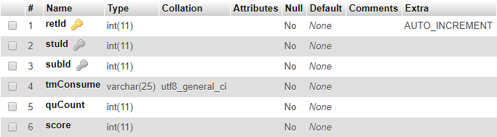

1. Student table

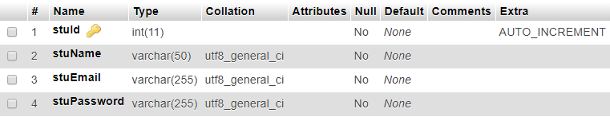

1. Subject table



1. Teacher table

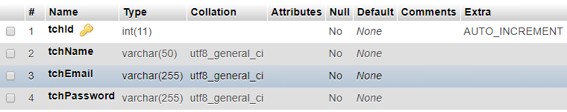

# Project description

We, a team of three engineers, Ms. Zhilin Lin, Mr. Zhaosheng Liu, and Mr. Peng Gao, take the assignment from our client Ms. Stephanie Moreau to design and develop an online quiz web application for her professional training school.

Our web application is developed with PHP backend language to handle the business logic. Applying composer technology with Meekro, and Twig. We applied MVC concept in designing the interactions between database, graphical user interface and business logic controller. Front end, we are using HTML, CSS and JavaScript to handle the visual design and interaction.

Two types of log-in design can separate the teacher and student user with different authorizations for the functionality and security concerns as part of online training school system.

Visually, our GUI is clean and simple, very user friendly. All the buttons, links and social media icons are active and laid out in a beautiful way.

# Things to improve

There are two places can be improved for this project in future:

* This system can only show the result of accuracy, but the true answer is not visible to students in result page. In the result page, we could add a button links to another page to show all the correct answers to each question of the subjected quiz.
* We developed four subjects’ quiz; each subject contains 5 questions as an initial launch. In future, it could be easily to expand more subjects and questions as client needs.
* The number of options of each question can decide by getting from user.
* The whole website can be integrated with fat-free framework.

Last but not the least, this project can be used as independent online quiz or test application. Moreover, it can be built as a module to be part of client’s entire school website in future.